**Output for XLS Extraction**

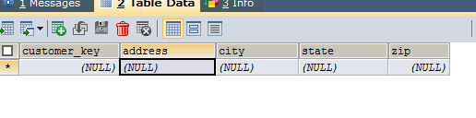

**After inserting:**

